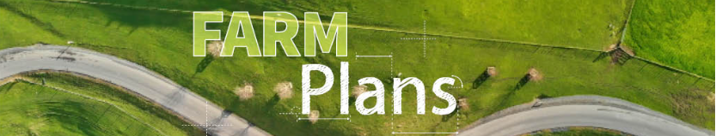

CERTIFIED FARM ENVIRONMENT PLAN

|  |
| --- |
| Farm Name: |
| Writer’s Name: |
| Date: |
| Catchment: |
| Certified by: |

*[Space to Insert picture from farm & remove Greater Wellington Logo]*



# 1.0 Farm overview

## 1.1 Farm story

Farm history:

Farm system & management overview:

Farm goals:

### 1.2 Property details

|  |  |
| --- | --- |
| Summary | |
| Property name |  |
| Address |  |
| Name and contact details (email/phone) |  |
| Legal description of land |  |
| Legal description and ownership of land parcels (if different from above) | [i.e., lease block information & owner’s details] |
| Farm identifiers |  |
| Irrigation scheme and water permits |  |
| Other consents i.e., discharge |  |

# 2.0 Catchment information

## 2.1 Catchment - Ruamāhanga Whaitua

## 2.2 Sub-catchment -

## 2.3 Challenges

|  |  |  |
| --- | --- | --- |
| Issue | Base grade | Objective |
| E-Coli |  |  |
| Periphyton |  |  |
| Ammonia toxicity |  |  |
| Nitrate toxicity |  |  |
| MCI |  |  |

## 2.4 Community values

## 2.5 Farm focuses

# 3.0 Land mangement units & inherent vulnerabilities

Land Management Units (LMU’s) are areas of land that can be farmed or managed in a similar way because of underlying physical similarities. These LMU’s have been based on the following………

## 3.1 Farm map – land management units

[Insert map identifying all LMU’s]

## 3.2 Land Management Unit 1: Name

**Description and management**

Insert LMU map here

**Inherent risks**

**Actions within this LMU**

## 3.3 Land Management Unit 2: Name

**Description and management**

Insert LMU map here

**Inherent risks**

**Actions within this LMU**

## 3.4 Land Management Unit 3: Name

**Description and management**

Insert LMU map here

**Inherent risks**

**Actions within this LMU**

## 3.5 Land Management Unit 4: Name

**Description and management**

Insert LMU map here

**Inherent risks**

**Actions within this LMU**

## 3.6 Land Management Unit 5: Name

**Description and management**

Insert LMU map here

**Inherent risks**

**Actions within this LMU**

# 4.0 Farming activities & risk assessment [Section 4 is required to be completed by a certifier]

## 4.1 Introduction

In identifying the level of risk specific to a farm the lands inherent vulnerabilities must be considered alongside the farming or growing activities occurring. Any catchment context information relevant to each identified risk must also be considered. To fully understand the level, location and type of risks with potential mitigations the risk assessment is conducted at LMU scale.

This table has been used to assist in the assessment of risks for each area (Nitrogen, Phosphorous, Sediment and E. Coli). For example, nitrogen through poor fertiliser application near a waterway has a serious consequence, and if the likelihood of it occurring is high then overall the risk is high, however if the likelihood is low then it is a low risk.

# 4.2 Nutrient management

### 4.2.1 Contaminants overview

Four key contaminants have been identified as problematic to New Zealand waterways: nitrogen (N), phosphorus (P), sediment, and *E. coli*.

The priority issue for my catchment is…………….

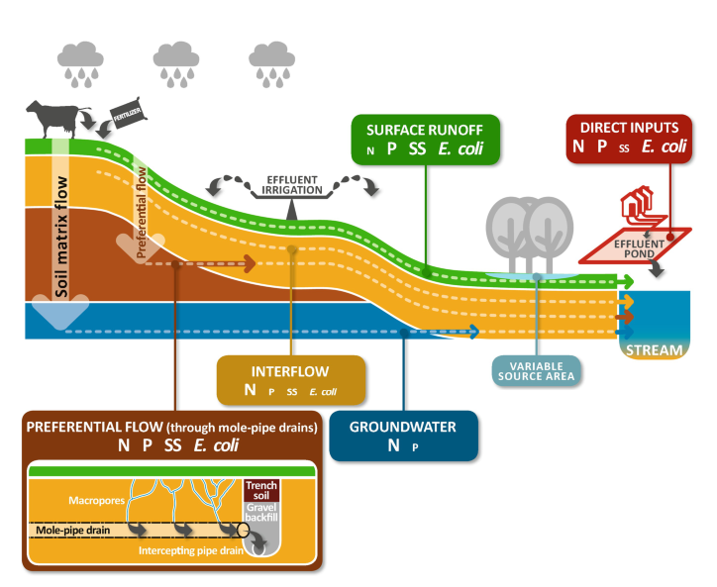The greatest risk on this farm for that these contaminants could enter waterways are……………….

### 4.2.2 Nitrogen

|  |  |  |  |  |  |  |  |
| --- | --- | --- | --- | --- | --- | --- | --- |
| Risk | Risk factors on your farm | Risk rating (High, Medium, Low) | | | | | |
|  | **Land Management Unit (LMU) or Paddock** | | | | |
| **Whole farm** | **1:** | **2:** | **3:** | **4:** | **5:** |
| Nitrogen loss risk  Nitrogen potentially entering waterways impacting freshwater health or drinking water quality | Animal loss risks: stock, feed type, grazing practices, off-paddock feeding | **Low** | **Medium** | **High** | **N/A** |  |  |
| Fertiliser loss risks: excessive nutrient levels (beyond plant needs), direct application to waterways |  |  |  |  |  |  |
| Effluent loss risks: overland flow, application beyond plant requirements |  |  |  |  |  |  |
| Nutrient transport risk: artificial drainage, soils, climate, topography, structural mitigations |  |  |  |  |  |  |

***Contaminant management and farm context:***

### 4.2.3 Phosphorus / sediment / E. coli

|  |  |  |  |  |  |  |  |
| --- | --- | --- | --- | --- | --- | --- | --- |
| Risk | Risk factors on your farm | Risk rating (High, Medium, Low) | | | | | |
|  | **Land Management Unit (LMU) or Paddock** | | | | |
| **Whole Farm** | **1:** | **2:** | **3:** | **4:** | **5:** |
| Sediment and Phosphorus loss risk  Sediment or phosphorus potentially entering waterways may cause excess algae growth, habitat loss or other harm to freshwater health | Erosion/Sediment loss risks: stock, grazing practices | **Low** | **Medium** | **High** | **N/A** |  |  |
| Cropping loss risks: cultivation |  |  |  |  |  |  |
| Fertiliser loss risks: excessive nutrient levels, direct application to waterways |  |  |  |  |  |  |
| Effluent loss risks: overland flow, application beyond plant requirements |  |  |  |  |  |  |
| Nutrient transport risks: artificial drainage, soils, climate, topography, structural mitigations |  |  |  |  |  |  |
| Faecal microbe loss risk  Contaminants, like pathogens such as *E. Coli*, potentially impacting on human health | Animal manure loss risks: stock, grazing practices |  |  |  |  |  |  |
| Nutrient transport risks: artificial drainage, soils, climate, topography, structural mitigations |  |  |  |  |  |  |

***Contaminant management and farm context:***

## 4.3 Critical source areas

### 4.3.1 Critical source areas (CSA)

### Point source areas

# 5.0 Action plan [Section 5 is required to be completed by a certifier]

## 5.1 Action plan table

| Identified Risk | Action to address risk | Location / LMU/Paddock | Timeline | Person responsible | Budget | Priority | Regulatory/ Supplementary / Catchment | Evidence of completion | Date completed | Expected outcome |
| --- | --- | --- | --- | --- | --- | --- | --- | --- | --- | --- |
|  |  |  |  |  |  |  |  |  |  |  |
|  |  |  |  |  |  |  |  |  |  |  |
|  |  |  |  |  |  |  |  |  |  |  |
|  |  |  |  |  |  |  |  |  |  |  |
|  |  |  |  |  |  |  |  |  |  |  |
|  |  |  |  |  |  |  |  |  |  |  |
|  |  |  |  |  |  |  |  |  |  |  |
|  |  |  |  |  |  |  |  |  |  |  |

|  |  |  |  |  |  |  |  |  |
| --- | --- | --- | --- | --- | --- | --- | --- | --- |
| Project: | Stock Exclusion / Fencing Waterways | | | | | Time: |  | |
| Area addressed: |  | | **Desired outcomes:** |  | | | | |
| Tasks | **Timeframe** | **Location:** | **Person responsible** | **People involved** | **Budget** | **Priority** | **Date completed** | **Evidence of completion** |
|  |  |  |  |  |  |  |  |  |
|  |  |  |  |  |  |  |  |  |
|  |  |  |  |  |  |  |  |  |
|  |  |  |  |  |  |  |  |  |
|  |  | | | | | | | |
|  |  | | | | | | | |

|  |  |
| --- | --- |
| Regulations to consider prior to undertaking recommended works [Above Sch Z requirement] | |
| Stock exclusion rules | Minimum setbacks and exclusion for new fences – [GW stock-exclusion-regulations](https://www.gw.govt.nz/environment/land-use/stock-exclusion-regulations/) |
| Mechanical Management of Highly Modified Waterways | https://www.gw.govt.nz/document/18185/good-practices-for-the-mechanical-management-of-highly-modified-waterways/ |
| Watercourse types | How to determine whether a watercourse is a river, ephemeral watercourse, highly modified river or stream, or artificial watercourse; https://www.gw.govt.nz/environment/land-use/watercourses/ |
|  |  |
|  |  |

# 6.0 Land Use & Stock Details

## 6.1 Farm summary

|  |  |
| --- | --- |
| Summary | Dairy |
| Total Farm Area (ha) |  |
| Effective Farm Area (ha) |  |
| Irrigated Area (ha) |  |
| Dryland Area (ha) |  |
| Intensive Winter Grazing Area (ha) |  |
| Farm system/type |  |
| Climate:  Average rainfall (mm)  Average temperature (OC)  Sunshine hours |  |

## 6.2 Dairy

|  |  |
| --- | --- |
| Summary |  |
| Peak cows milked |  |
| Cow breed |  |
| Once per day milking |  |
| Average milking cow live weight |  |
| Replacement rate |  |
| Milk solids per cow per year |  |
| Non lactating stock |  |

*[Description or general overview of current and intended future practise]*

## 2 Sheep and Beef

|  |  |
| --- | --- |
| Summary | Year |
| Peak Breeding Sheep numbers |  |
| Lambing % |  |
| Peak Cattle numbers |  |
| Calving % |  |
| Total Stock units |  |
| Sheep:cattle ratio |  |
| Stock units/grazeable ha |  |

*[Description or general overview of current and intended future practise]*

## 6.3 Crop

|  |  |  |
| --- | --- | --- |
| Crop | Year | Year |
| Area (ha) |  |  |
| Yield (t DM/ha) |  |  |
| Month Sown |  |  |
| Cultivation Method |  |  |
| Month/s Harvested |  |  |
| Post Crop Treatment |  |  |
| Stock Grazing |  |  |

*[Description of current and intended future practise]*

## 6.4 Other farm management practice

## 6.5 Farm Infrastructure

|  |  |
| --- | --- |
| Type | Description |
| Culverts |  |
| Irrigation Pivot |  |
| Unmanaged crossings |  |
| Effluent Pond |  |
| Feed pad |  |
| Offal Pit |  |
| Silage stack |  |
| Yards |  |
| Old Sheds |  |
| Milk shed |  |
| Hay shed |  |
| Chemical storage |  |
| Fuel Storage |  |
| Fertiliser storage |  |
| Farm laneways / Tracks |  |
| Farm dump |  |
| Other |  |

## 6.6 Nutrient Information

|  |  |  |  |  |  |  |
| --- | --- | --- | --- | --- | --- | --- |
| Block | Fertiliser product  (Month applied) | Rate of application  (kg/ha) | Nutrients applied (kg/ha) | | | |
|  | | | ***N*** | ***P*** | ***K*** | ***S*** |
|  |  |  |  |  |  |  |
|  |  |  |  |  |  |  |
|  |  |  |  |  |  |  |
|  | | Total Nutrient applied (kg/ha) |  |  |  |  |

*[Description or general overview of current and intended future practise]*

## 6.7 Soil test

|  |  |  |  |  |  |
| --- | --- | --- | --- | --- | --- |
| LMU | pH | Olsen P | Potassium |  | Potentially Available N (Crop Pdks) |
| 1 |  |  |  |  |  |
| 2 |  |  |  |  |  |
| 3 |  |  |  |  |  |
| 4 |  |  |  |  |  |
| 5 |  |  |  |  |  |

*[Overview of historic soil test levels and intended future levels you are wanting to increase, decrease or maintain]*

## 6.8 Supplementary feed information

|  |  |  |  |  |
| --- | --- | --- | --- | --- |
| Feed type | Source | Amount (t DM) | Distributed location | Storage type |
|  |  |  |  |  |
|  |  |  |  |  |
|  |  |  |  |  |

*[Overview of where supplementary feed is sourced from, stored, how feed out and seasonal timing]*

## 6.9 Irrigation Management

|  |  |
| --- | --- |
| Water Permit/Consent Details - | |
| Take type i.e. surface or groundwater |  |
| Expiry date |  |
| Maximum take (Monthly/Yearly) |  |
| Consented irrigation area (if applicable) |  |
| Any restrictions? |  |
| Natural Resources Plan  Efficient use criteria (Policy P118): |  |

*[Full details & conditions required]*

|  |  |
| --- | --- |
| Water Permit/Consent Details – | |
| Take type i.e. surface or groundwater |  |
| Expiry date |  |
| Maximum take (Monthly/Yearly) |  |
| Consented irrigation area (if applicable) |  |
| Irrigation rate |  |
| Potential restrictions |  |
| Natural Resources Plan  Efficient use criteria (Policy P118): |  |

*[Full details & conditions required]*

|  |  |  |
| --- | --- | --- |
| Irrigation Type | Pivot/Linear | Sprinklers (K-Line, Long-Line Sprinklers) |
| Irrigation Area (ha) |  |  |
| Rotation length |  |  |
| Application rate (mm) |  |  |
| Irrigation season start and end date |  |  |
| Decision making tools |  |  |

## 6.10 Effluent Management

|  |  |
| --- | --- |
| Consent/Permit details . | |
| Expiry date: |  |
| Irrigation Area: |  |
| Application depth |  |
| Nitrogen loading |  |
| Other consent conditions of note |  |
| Effluent Management Details | |
| Storage type (i.e. 2 pond system, solid separator to pond) |  |
| Storage volume m3  Storage days |  |
| Irrigator Type |  |
| Tested application depth mm |  |
| Fail safe/s |  |
| Notes: | |

*[Full details & conditions required]*

# 7.0 Farm maps

|  |  |  |
| --- | --- | --- |
| Map | Applicable (Yes or NA) | Map (name or number) |
| The property boundaries of the land being farmed |  |  |
| The boundaries of the main land management units or land uses on the land being farmed |  |  |
| The catchment and sub-catchment that the farm is within and a map showing the location of the farm within the sub catchment |  |  |
| Soil types and topography at 1:50,000 scale |  |  |
| The location (and for named waterbodies, the names) of any permanently or intermittently flowing waterbodies on the property including;   * rivers, * streams, * drains, * wetlands, * lakes, and * springs, and * specifically identifying any waterbodies that meet the criteria for stock exclusion in the Regional Plan and/or Resource Management (Stock Exclusion) Regulations 2020 |  |  |
| The location of any site or river included in Schedules B, C, F1 and F3 of the Plan that is within, or adjacent to, the property |  |  |
| The location of riparian vegetation and fences (or other stock proof barriers adjacent to water bodies) |  |  |
| The location of any stock crossing points or structures on any water bodies where stock have access |  |  |
| The location of any critical source areas, and hotspots for contaminant loss to groundwater or surface water |  |  |
| The location of any surface and (where known) sub-surface drains |  |  |
| The location(s) of the actions and practices that will be adopted to ensure the effective management of contaminant loss on the farm [Required to be completed by a certifier] |  |  |
| Any other feature or characteristic of the land necessary to assess the risk factors set out in Tables 1 to 3;   * Effluent applications including liquids and solids * Animal types * Erosion/sediment issues * Cropping areas |  |  |

## 7.1 Farm map – Sub-catchment

## 7.2 Farm map – Soils

## 7.3 Farm maps – Waterways and sites of significance

## 7.4 Farm map –Waterway types and crossings

## 7.5 Farm map –Riparian planting

## Farm map –Critical source areas

## 7.7 Farm map – Infrastructure

# 8.0 Appendix A – Dairy Farm Mitigations/Good Management Practices (GMPs)

|  |  |
| --- | --- |
| Risk | Mitigation/GMP |
| Soil structure degradation, including erosion through run-off, and wind blow. Soil compaction, e.g., pugging |  |
| Nutrient contamination to waterways |  |
| Nutrient loss |  |
| Nutrient loss |  |
| Nutrient loss |  |
| Nutrient loss |  |
| Nutrient loss |  |
| Nutrient loss |  |
| Nutrient loss |  |
| Soil damage/compaction.  Nutrient, sediment, e.coli loss |  |
| Nutrient, sediment, e.coli loss |  |
| Nutrient loss |  |
| Rubbish |  |
| Contaminant loss to waterways |  |
| Contaminant loss |  |

# 9.0 Soil Nutrient Risk Table

Identifying and understanding soil type’s and their limitation is important, these should be accounted for when making land management decisions.

|  |  |  |  |  |  |
| --- | --- | --- | --- | --- | --- |
| Soil Sibling  [Soil map colour] | Common Names | LMU’s | Drainage Class | Structure & Leaching | Texture |
|  |  |  |  |  |  |
|  |  |  |  |  |  |
|  |  |  |  |  |  |
|  |  |  |  |  |  |
|  |  |  |  |  |  |
|  |  |  |  |  |  |

# 10.0 Appendix B – Catchment information